 | A-1 Information Systems  Phone: Fax: |  | 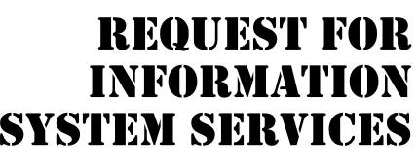
DATE OF REQUEST |  | SERVICE REQUESTED FOR DEPARTMENT(S)
13/10/2024 |  | Human Resources

SUBMITTED BY (key user contact) | EXECUTIVE SPONSOR (funding authority)
Name Dottie Jones | Name Jack Mills
Title HR Subject Matter Expert | Title Vice President of Human Resources
Office Room 2 | Office Room 1
Phone (111) 222-3333 | Phone (111) 234-5678

TYPE OF SERVICE REQUESTED:
Information Strategy Planning Existing Application Enhancement
Business Process Analysis and Redesign Existing Application Maintenance (problem fix)
New Application Development Not Sure
Other (please specify _______________________________________________________________________

BRIEF STATEMENT OF PROBLEM, OPPORTUNITY, OR DIRECTIVE (attach additional documentation as necessary)

The Human Resources (HR) department currently relies on manual processes for updating employee information, such as address changes, payroll deductions, and time and attendance. These outdated methods cause significant delays in updating the payroll, which leads to inaccurate paychecks and incorrect mailing addresses. The printed employee directory is frequently outdated due to delays in updates of information, which impacts effective communication across the company. There is a pressing need to streamline HR operations to improve efficiency and accuracy.

BRIEF STATEMENT OF EXPECTED SOLUTION

The Employee Self-Service System (ESSS) will provide employees with the ability to update their personal information in real-time through a secure online platform, eliminating the need for HR to manually enter updates. This will minimize errors in payroll and mailing addresses. Additionally, the system will include an online employee directory hosted on the company intranet, which will be automatically updated whenever employee information changes, ensuring it is always current. Employee training will be provided to facilitate smooth adoption of the new system. Minimal infrastructure upgrades are anticipated.

ACTION (ISS Office Use Only)
Feasibility assessment approved Assigned to _<Student’s Name>_

Feasibility assessment waived Approved Budget $ _____________
Start Date __ _____ Deadline _ ___
Request delayed Backlogged until date: ______________
Request rejected Reason: ________________________________________________
Authorized Signatures:
_____________________________________ _________________________________________________
Project Executive Sponsor

